System and Software Architecture Description (SSAD)

Los Angeles Child Guidance Clinic Employment Opportunities Online Application System

Team#10

1) Lawrence Aung
lawrenca@usc.edu
Project Manager

2) Adarsh Khare
akhare@usc.edu
Life Cycle Planner

3) Eric Hu
ehu@usc.edu
Feasibility Analyst

4) Sonesh Suryawanshi
suryawan@usc.edu
System Architect

5) Siva Soumya Mandadi
mandadi@usc.edu
Requirements Engineer

6) Colin Crenshaw
ccrensha@usc.edu
IIV & V

December 12, 2011

Version History
Date | Author | Version | Changes made | Rationale
10/07/11 | LA | 1.0 | - Initial SSAD, with UML Class Diagrams and UML Use-Case Diagrams | - For the Core FCP Submission
10/11/11 | LA | 1.1 | - Changes to System Context and Behavior | - After a better clarification meeting with the clients
10/14/11 | SS | 1.2 | - Included modes of operation and  System analysis rationale | - For the draft FCP submission
10/14/11 | LA | 1.3 | - Updated changes as per Core FCP results | - For the Draft FCP submission
10/17/11 | LA | 1.4 | - Updated Artifacts table to include more descriptive variable names + more minor changes | - For the FCR ARB
10/24/11 | LA | 2.0 | - Added Administrator User along with some minor updates from ARB review | - For the FCP
11/21/11 | SS | 2.1 | - Added technology dependent model | - For DCP and ARB
12/05/11 | SS | 2.2 | Made changes from DCP Comments | - For DCP
12/12/11 | SS | 2.3 | Changes from DCP | For archiving

Table of Contents
System and Software Architecture Description (SSAD) i
Version History ii
Table of Contents iii
Table of Tables iv
Table of Figures vi
1. Introduction 1
1.1 Purpose of the SSAD 1
1.2 Status of the SSAD 1
2. System Analysis 2
2.1 System Analysis Overview 2
2.2 System Analysis Rationale 24
3. Technology-Specific System Design 25
3.1 Design Overview 25
3.2 Design Rationale 34
4. Architectural Styles, Patterns and Frameworks 36

Table of Tables
Table 1: Actors Summary 4
Table 2: Artifacts and Information Summary 5
Table 3: Process Description 8
Table 4: Typical Course of Action 8
Table 5: Alternate Course of Action 8
Table 6: Process Description 9
Table 7: Typical Course of Action 9
Table 8: Alternate Course of Action 9
Table 9: Process Description 10
Table 10: Typical Course of Action 10
Table 11: Process Description 10
Table 12: Typical Course of Action 11
Table 13: Process Description 11
Table 14: Typical Course of Action 11
Table 15: Alternate Course of Action 11
Table 16: Alternate Course of Action 12
Table 17: Process Description 12
Table 18: Typical Course of Action 13
Table 19: Process Description 13
Table 20: Typical Course of Action 13
Table 21: Process Description 14
Table 22: Typical Course of Action 14
Table 23: Process Description 14
Table 24: Typical Course of Action 15
Table 25: Alternate Course of Action 15
Table 26: Process Description 15
Table 27: Typical Course of Action 16
Table 28: Process Description 16
Table 29: Typical Course of Action 16
Table 30: Process Description 17
Table 31: Typical Course of Action 17
Table 32: Process Description 17
Table 33: Typical Course of Action 18
Table 34: Alternate Course of Action 18
Table 35: Process Description 18
Table 36: Typical Course of Action 18
Table 37: Process Description 19
Table 38: Typical Course of Action 19
Table 39: Alternate Course of Action 19
Table 40: Process Description 19
Table 41: Typical Course of Action 20
Table 42: Alternate Course of Action 20
Table 43: Process Description 20
Table 44: Typical Course of Action 21
Table 45: Alternate Course of Action 21
Table 46: Alternate Course of Action 21
Table 47: Process Description 22
Table 48: Typical Course of Action 22
Table 49: Typical Course of Action 22
Table 50: Process Description 23
Table 51: Typical Course of Action 23
Table 52: Alternate Course of Action 23
Table 53: Process Description 23
Table 54: Typical Course of Action 24
Table 55: Hardware Component Description 27
Table 56: Software Component Description 27
Table 57: Design Class Description 28
Table 58: Design Class Description 29
Table 59: Design Class Description 30
Table 60: Design Class Description 31
Table 61: Architectural Styles, Patterns, and Frameworks 36

Table of Figures
Figure 1: System Context Diagram 3
Figure 2: Artifacts and Information Diagram 5
Figure 3: Process Diagram 7
Figure 4: Hardware Component Class Diagram 25
Figure 5: Software Component Class Diagram 26
Figure 6: Deployment Diagram 27
Figure 7: Design Class Diagram 28
Figure 8: Design Class Diagram 29
Figure 9: Design Class Diagram 30
Figure 10: Design Class Diagram 31

Introduction

Purpose of the SSAD

This document will clarify the functionality of our proposed system, including user definitions, expected artifacts, and user capabilities.

Status of the SSAD
This version of SSAD contains modes of operation for the system, system analysis rationale. This version also contains modifications from the previous version of SSAD.

System Analysis

System Analysis Overview
The primary purpose of the Online Application System is to modernize the way candidates apply for jobs at the Los Angeles Child Guidance Clinic. The Online Application System should keep track of the Applicant's information in the system, allowing Human Resource Employees an automated and standardized method of filtering through applications, creating and editing job postings to be displayed online, and keeping track of previous and current job postings and applicants (for data and future job openings). The IT maintainer should be able to back up old applications such as to prevent data overload within the system. Reports should also be easy to compile for end of the year hiring data evaluation.

System Context
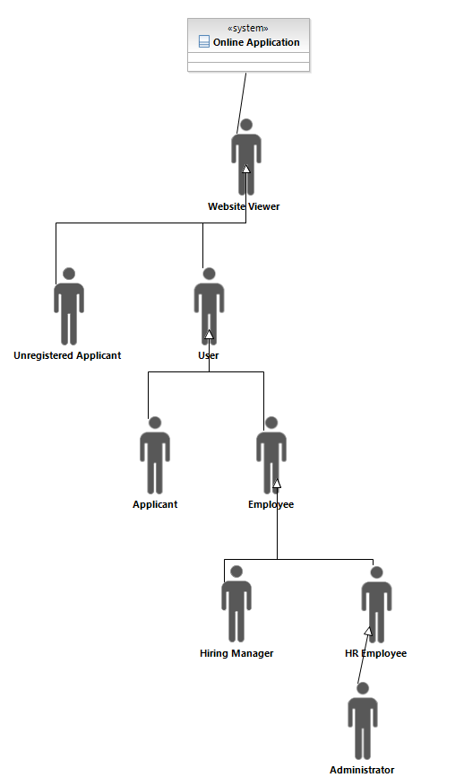
Figure 1: System Context Diagram

Table 1: Actors Summary
Actor | Description | Responsibilities
Administrator | Likely an IT Maintainer, this person will be able to manage accounts on the employee side | - Create an Account for a Hiring Manager or HR Employee  - Delete Accounts
Hiring Manager | The managers with open positions to be filled. They will ultimately choose the candidate to be hired. | - Select Interview Candidates  - Choose from those Interview Candidates who they would like to hire
HR Employee | Employees who work within the HR department, currently Reina Davis and Rick Marquez | - Add/Update/Delete Job Postings  - Evaluate potential job candidates  - Mark candidates for backup from the system  - Run background checks on the candidate chosen by the hiring manager  - Produce end of the year graphs to show the board
Employee | This is an employee who works at the LACGC, in other words either a HR Employee or a Hiring Manager | - Capability to view, filter, and sort Applicants
Applicant | Job Seeking Person | - Fills out the application online  - Uploads any relevant documents appropriately  - Can be easily reached based on contact information from the system
User | This is a person known in the system; either an employee or a registered applicant | - Has access to the System
Unregistered Applicant | Job Seeking Person without an account | - Register for an Account before applying
Website Viewer | Generally, anyone who goes to the LACGC website | - View the job postings available

Artifacts & Information
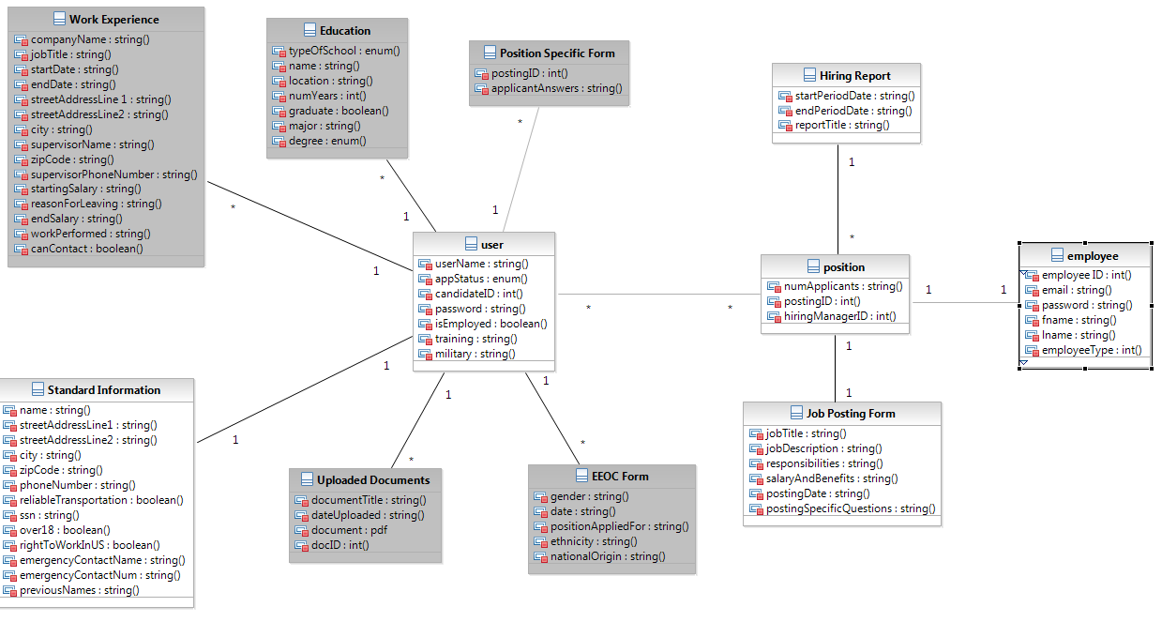
Figure 2: Artifacts and Information Diagram
Table 2: Artifacts and Information Summary
Artifact | Purpose
Standard Information | Basic information common to all applications, such as address, phone number, and prior experience; Note: this information will not be archived if applicant is "archived"
Position Specific Form | Dynamic Information that can change between each position. The Applicant will answer all questions in a singular text box, and the question will be referred to by the Posting ID. Note: this information will be archived if applicant is "archived"
Uploaded Document | Any sort of attachment that are required for application; Note: this information will be archived if applicant is "archived"
Education | Information related to the Candidate's Education; Note: this information will be archived if applicant is "archived"
Work Experience | Information related to the Candidate's Prior Work Experience; Note: this information will be archived if applicant is "archived"
EEOC Form | Form with questions required by the EEOC; Note: this information will be archived if applicant is "archived"
User (Candidate Profile) | Basic Information kept about each Applicant; Note: this information will not be archived
Job-Specific Candidate Info | This is information relating a candidate to a job. Because an applicant may apply to multiple positions, this information describes the candidate per each position he/she has applied for. This information will not be archived.
Job Posting Form | Information about each posting, such as the title, job description, and any required documents/questions. Note: this information can be archived
Position (Job Posting) | Basic Information kept about each Job Posting
Hiring Report | Report produced for the board of directors about hiring practices
Employee | This contains information about employees within the system. It can be used to represent administrators, HR employees, and hiring managers

Behavior
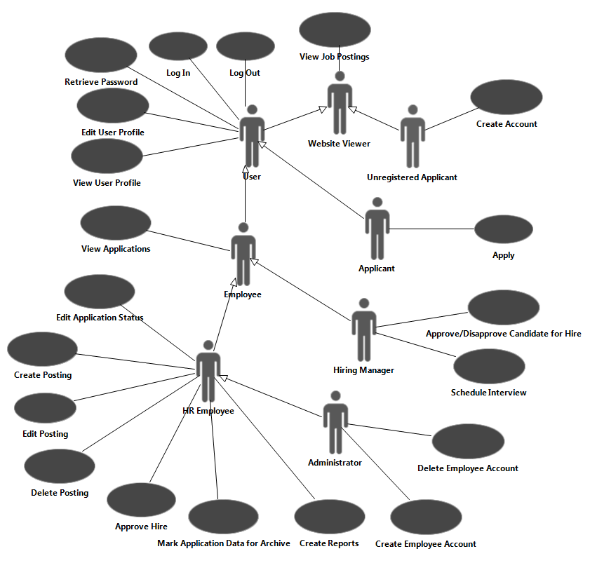
Figure 3: Process Diagram

Job Posting Management

Post a Job Position
Table 3: Process Description
Identifier | UC-1: Create a Job Posting
Purpose | Allow HR Employees to Post New Job Positions
Requirements | CR-4: Generation of EEOC form,  CR-5: Ability to add/edit job positions by HR or IT dept,  CR-13: Flexibility in the Application,  CR-14: Attachments need to be handled
Development Risks
Pre-conditions | User is a logged in HR Employee
Post-conditions | Posting is Created in the System, and can be viewed online

Table 4: Typical Course of Action
Seq# | Actor’s Action | System’s Response
1 | User fills out relevant information about the posting, including position-specific data
2 | Clicks Create
3 |  | System generates posting identification data
4 |  | Posting is created in the system
5 |  | System generates a message to inform the User of successful post creation
Table 5: Alternate Course of Action
Seq# | Actor’s Action | System’s Response
1 | User does not completely fill out the relevant information
2 | Clicks Create
3 |  | System generates a message to inform the User of his/her mistake
4 |  | Posting is not created in the system

Edit a Posted Job Position
Table 6: Process Description
Identifier | UC-2: Edit a Posted Job Posting
Purpose | Allow HR Employees to Edit Existing Job Positions
Requirements | CR-5: Ability to add/edit job positions by HR or IT dept,  CR-13: Flexibility in the Application,  CR-14: Attachments need to be handled
Development Risks
Pre-conditions | User is a logged in HR Employee and Job Posting is already created
Post-conditions | Posting is edited in the System, and can be viewed online

Table 7: Typical Course of Action
Seq# | Actor’s Action | System’s Response
1 | User selects the appropriate posting and clicks Edit
2 |  | System retrieves the posting selected
3 | User fills out relevant information about the posting
4 | Clicks Submit
5 |  | System modifies posting identification data
6 |  | Changes are saved in the system
7 |  | System generates a message to inform the User of successful post edit
Table 8: Alternate Course of Action
Seq# | Actor’s Action | System’s Response
1 | User selects the appropriate posting and clicks Edit
2 |  | System retrieves the posting selected
3 | User does not completely fill out the relevant information
4 | Clicks Create
5 |  | System generates a message to inform the User of his/her mistake
6 |  | Changes are not saved in the system

Delete a Posted Job Position
Table 9: Process Description
Identifier | UC-3: Delete a Posted Job Posting
Purpose | Allow HR Employees to Delete Existing Job Positions
Requirements | CR-6: Ability to delete the filled job post
Development Risks
Pre-conditions | User is a logged in HR Employee and Job Posting is already created
Post-conditions | Posting is archived by the System, and can no longer be viewed online

Table 10: Typical Course of Action
Seq# | Actor’s Action | System’s Response
1 | User selects the appropriate posting
2 | Clicks Delete
3 |  | System archives the posting
4 |  | System removes the posting from online view
5 |  | System informs User of the successful post deletion

Application Process

View Job Posting
Table 11: Process Description
Identifier | UC-4: View Job Posting
Purpose | Allow Users to view Existing Job Positions
Requirements | CR-1: Collection of Applicant Data
Development Risks
Pre-conditions | Posting exists in the System
Post-conditions | Job posting is retrieved and displayed

Table 12: Typical Course of Action
Seq# | Actor’s Action | System’s Response
1 | User selects the appropriate postings that he wishes to view
2 |  | System returns information about that specific posting

Apply
Table 13: Process Description
Identifier | UC-5: Apply
Purpose | Allow Users to Apply to Existing Job Positions
Requirements | CR-1: Collection of Applicant data,  CR-7: Allow Applicants to apply to multiple positions,  CR-14: Attachments need to be handled
Development Risks
Pre-conditions | User is a logged in Applicant and Job Posting is already created
Post-conditions | User is added to list of applicants for that specific Job Posting

Table 14: Typical Course of Action
Seq# | Actor’s Action | System’s Response
1 | User selects the appropriate postings that he is interested in
2 |  | System retrieves the posting selected
3 | User fills out relevant data that cannot be taken from his profile
4 | User uploads relevant documents
5 |  | System responds with a message confirming that documents were uploaded
6 | Clicks Submit
7 |  | System adds candidate to applicant list for the specific posting
8 |  | System generates a message to inform User of his successful application
Table 15: Alternate Course of Action
Seq# | Actor’s Action | System’s Response
1 | User selects the appropriate posting that he is interested in
2 |  | System retrieves the posting selected
3 | User does not completely fill out the information he fills out
4 | Clicks Submit
5 |  | System generates a message to inform the User of his/her mistake
6 |  | System does not add candidate to applicant list for the specific posting
Table 16: Alternate Course of Action
Seq# | Actor’s Action | System’s Response
1 | User selects the appropriate posting that he is interested in
2 |  | System retrieves the posting selected
3 | User fills out relevant data that cannot be taken from his profile
4 | User chooses not to upload relevant documents
5 | Clicks Submit
6 |  | System generates a message to inform the User of the required documents needed, but also notes the success of his/her application
7 |  | System adds candidate to applicant list, but notes missing documents

View Applications
Table 17: Process Description
Identifier | UC-6: View Applications
Purpose | Allow HR Employees and Hiring Managers to Review to Applications for Existing Job Positions
Requirements | CR-1: Collection of Applicant data,  CR-2: Ability to search Applicant data on various criteria
Development Risks
Pre-conditions | User is a logged in HR Employee or Hiring Manager, a Job Posting is already created, and Applicants have already applied
Post-conditions | User receives a sortable/filter-able list of all of the applicants who have applied to the position

Table 18: Typical Course of Action
Seq# | Actor’s Action | System’s Response
1 | User selects the appropriate posting that he is interested in reviewing
2 |  | System returns all of the applicants who have applied to the position so far; If User is a Hiring Manager, System only shows qualified candidates
3 | User sorts/filters the applicants as he pleases
4 |  | System returns the applicants that match the sort/filter

Edit Application Status
Table 19: Process Description
Identifier | UC-7: Edit Application Status
Purpose | Allow HR Employees to label a potential candidate as Qualified, Unqualified, Processing, etc.
Requirements | CR-10: Track multiple position applications with same applicant separately  CR-12: A status of the application should be provided
Development Risks
Pre-conditions | User is a logged in HR Employee, a Job Posting is already created, and Applicants have already applied; If Processing, Applicant must have been approved for hire by Hiring Manager
Post-conditions | A flag in the Applicant data is set

Table 20: Typical Course of Action
Seq# | Actor’s Action | System’s Response
1 | User selects the appropriate applicant and views his/her profile
2 |  | System returns the correct applicant
3 | User marks the user as either qualified, unqualified, or processing
4 |  | System modifies the Applicant profile to reflect User's change

Schedule Interview
Table 21: Process Description
Identifier | UC-8: Schedule Interview
Purpose | Allow Hiring Managers to label potential candidates as interviewing (in case of scenarios where a single applicant is being considered for multiple positions)
Requirements | CR-10: Track multiple position applications with same applicant separately  CR-12: A status of the application should be provided
Development Risks
Pre-conditions | User is a logged in Hiring Manager, a Job Posting is already created, and Applicants have already been marked as qualified
Post-conditions | Candidate status is set to as "Being Interviewed" by the Hiring Manager User

Table 22: Typical Course of Action
Seq# | Actor’s Action | System’s Response
1 | User looks through a list of qualified applicants as deemed by the HR Employee
2 | User selects the appropriate applicant and views his/her profile
3 |  | System returns the correct applicant
4 | User marks the user as interviewing
5 |  | System modifies the Applicant profile to reflect User's change

Approve/Disapprove Candidate for Hire
Table 23: Process Description
Identifier | UC-9: Approve/Disapprove Candidate for Hire
Purpose | Allow Hiring Managers to label potential candidates as approved/disapproved for a position
Requirements | CR-10: Track multiple position applications with same applicant separately,  CR-12: A status of the application should be provided
Development Risks
Pre-conditions | User is a logged in Hiring Manager, a Job Posting is already created, and Applicant's status is Interviewing
Post-conditions | A flag in the Applicant data is set; If disapproved, applicant is put back into availability pool

Table 24: Typical Course of Action
Seq# | Actor’s Action | System’s Response
1 | User selects the appropriate applicant
2 |  | System returns the correct applicant
3 | User marks the user as approved
4 |  | System modifies the Applicant profile to reflect User's change

Table 25: Alternate Course of Action
Seq# | Actor’s Action | System’s Response
1 | User selects the appropriate applicant
2 |  | System returns the correct applicant
3 | User marks the user as disapproved
4 |  | System modifies the Applicant profile to reflect User's change. Applicant is set back to qualified status so other Hiring Managers can interview him/her

Approve Hire
Table 26: Process Description
Identifier | UC-10: Approve Hire
Purpose | Allow the HR Employee to label a candidate as hired
Requirements | CR-12: A status of the application should be provided
Development Risks
Pre-conditions | User is a logged in HR Supervisor, a Job Posting is already created, and Applicants have already applied
Post-conditions | Candidate status is set as "Approved for Hire" by Hiring Manager User

Table 27: Typical Course of Action
Seq# | Actor’s Action | System’s Response
1 | User selects the appropriate applicant and views his/her profile
2 |  | System returns the correct applicant
3 | User marks the user as either hired or not hired
4 |  | System modifies the Applicant profile to reflect User's change

Create Reports
Table 28: Process Description
Identifier | UC-11: Create Reports
Purpose | Allow the HR Employee to export Reports about Hiring data
Requirements | CR-3: Generation of reports in Excel form
Development Risks
Pre-conditions | User is an HR Employee
Post-conditions | System Outputs Hiring Data in a report form

Table 29: Typical Course of Action
Seq# | Actor’s Action | System’s Response
1 | User selects an appropriate time period to look for data
2 |  | System returns data from the time period
3 | User selects Export Report
4 |  | System outputs its Hiring Data in a readable format

Archiving Data

Mark Application Data for Archive
Table 30: Process Description
Identifier | UC-12: Mark Application Data for Archive
Purpose | Allow the HR Employee to mark applicants as ready to be archived
Requirements | CR-15: Archiving of historic data for at least one year
Development Risks
Pre-conditions | User is an HR Employee, there exists an Applicant to be archived
Post-conditions | System sets a flag in the Applicant Profile saying it is ready to be archived

Table 31: Typical Course of Action
Seq# | Actor’s Action | System’s Response
1 | User selects an existing Applicant
2 |  | System returns the correct Applicant
3 | User selects Mark for Archive
4 |  | System sets a flag in the Applicant Profile

Authentication System

Log In
Table 32: Process Description
Identifier | UC-13: Log In
Purpose | Allow a User to log into the system
Requirements | CR-8: Log in functionality for applicants, HR employees, and IT department
Development Risks | Sufficient Security Required to protect valuable applicant data
Pre-conditions | User has an account in the system
Post-conditions | User is logged into the system

Table 33: Typical Course of Action
Seq# | Actor’s Action | System’s Response
1 | User enters in his/her username and password
2 | User selects Log In
3 |  | System checks to ensure that the User is in the system/has correct credentials
4 |  | System logs the user in

Table 34: Alternate Course of Action
Seq# | Actor’s Action | System’s Response
1 | User enters in incorrect username and/or password
2 | User selects Log In
3 |  | System checks to ensure that the User is in the system/has correct credentials
4 |  | System informs the User of the mistake
5 |  | System does not log the User in

Log Out
Table 35: Process Description
Identifier | UC-14: Log Out
Purpose | Allow a User to log out of the system
Requirements | CR-8: Log in functionality for applicants, HR employees, and IT department
Development Risks | Sufficient Security Required to protect valuable applicant data
Pre-conditions | User has an account in the system and is currently logged into the system
Post-conditions | User is logged out of the system

Table 36: Typical Course of Action
Seq# | Actor’s Action | System’s Response
1 | User selects Log Out
2 |  | System logs the user out

Create Account
Table 37: Process Description
Identifier | UC-15: Create Account
Purpose | Allow a User to create an account within the system
Requirements | CR-8: Log in functionality for applicants, HR employees, and IT department
Development Risks | Sufficient Security Required to protect valuable applicant data
Pre-conditions | User does not have an account within the system (is an Unregistered Applicant)
Post-conditions | User's account is created in the system

Table 38: Typical Course of Action
Seq# | Actor’s Action | System’s Response
1 | User selects Create an Account
2 |  | System returns a standard information form to fill out to create an account
3 | User fills out all of the required data correctly
4 |  | System creates an account for the User
Table 39: Alternate Course of Action
Seq# | Actor’s Action | System’s Response
1 | User selects Create an Account
2 |  | System returns a standard information form to fill out to create an account
3 | User does not fill out all of the required data or fills out the data incorrectly
4 |  | System informs the User of the missing/incorrect required data
5 |  | System does not create an account for the User

Retrieve Password
Table 40: Process Description
Identifier | UC-16: Retrieve Password
Purpose | Allow a User to retrieve a password for an account within the system
Requirements | CR-8: Log in functionality for applicants, HR employees, and IT department
Development Risks
Pre-conditions | User has a legitimate account within the system
Post-conditions | An email is sent to the email account attached to the account within the system

Table 41: Typical Course of Action
Seq# | Actor’s Action | System’s Response
1 | User fills out the account's id/email with a legitimate account/email within the system
2 | User selects Forgot Password
3 |  | System sends an email to the account's email
Table 42: Alternate Course of Action
Seq# | Actor’s Action | System’s Response
1 | User fills out the account's id/email with an illegitimate account/email within the system
2 | User selects Forgot Password
3 |  | System informs the User of the lack of an account
4 |  | System does not send any emails

Create Employee Account
Table 43: Process Description
Identifier | UC-17: Create Employee Account
Purpose | Allow an Administrator to create an account for an Employee in the system
Requirements | CR-8: Log in functionality for applicants, HR employees, and IT department
Development Risks | Sufficient Security Required to protect valuable applicant data
Pre-conditions | User is an administrator, and new user does not have an account in the system
Post-conditions | New user has an account in the system

Table 44: Typical Course of Action
Seq# | Actor’s Action | System’s Response
1 | User enters in a unique login name for the new user
2 |  | System tells the User that the login name is available
3 | User fills in the rest of the details for the new user (name and email address)
4 |  | System checks to ensure that the new user has correct credentials
5 |  | System creates an account for the user and sends an email to the address provided, with temporary password)
6 |  | System tells the User that the account has been created and the email has been sent

Table 45: Alternate Course of Action
Seq# | Actor’s Action | System’s Response
1 | User enters in a unique login name for the new user
2 |  | System tells the User that the login name is available
3 | User doesn't fill in or improperly fills in the rest of the details for the new user (name and email address)
4 |  | System notices that the User has input improper credentials
5 |  | System tells the User that the account has not been created and that values need to be fixed
Table 46: Alternate Course of Action
Seq# | Actor’s Action | System’s Response
1 | User enters in a non-unique login name for the new user
2 |  | System tells the User that the login name is not available

Delete Account
Table 47: Process Description
Identifier | UC-18: Delete Account
Purpose | Allow an Administrator to create an account for an Employee in the system
Requirements | CR-8: Log in functionality for applicants, HR employees, and IT department
Development Risks | Sufficient Security Required to protect valuable applicant data
Pre-conditions | User is an administrator, and other user has an account in the system
Post-conditions | Selected User no longer has an account within the system

Table 48: Typical Course of Action
Seq# | Actor’s Action | System’s Response
1 | User selects a user to delete and clicks delete.
2 |  | System asks the User to confirm his deletion
3 | User confirms his choice.
4 |  | System removes the account from the authentication system
5 |  | System tells the User that the account has been deleted

Table 49: Typical Course of Action
Seq# | Actor’s Action | System’s Response
1 | User selects a user to delete and clicks delete.
2 |  | System asks the User to confirm his deletion
3 | User cancels his choice.
4 |  | System tells the User that the account has not been deleted

User Profile

Edit User Profile
Table 50: Process Description
Identifier | UC-19: Edit User Profile
Purpose | Allow Users to edit their profile
Requirements | CR-9: Applicants allowed to update their profile
Development Risks
Pre-conditions | Applicant has an account in the system
Post-conditions | Applicant has new data in the system

Table 51: Typical Course of Action
Seq# | Actor’s Action | System’s Response
1 | User enters in the new values he or she wants to save
2 | User selects the "Save" Button
3 |  | System saves the data in the database
4 |  | System informs the User of the success
Table 52: Alternate Course of Action
Seq# | Actor’s Action | System’s Response
1 | User enters in improper values into the form fields
2 | User selects the "Save" Button
3 |  | System informs the User of the improper data fields

View User Profile
Table 53: Process Description
Identifier | UC-20: View User Profile
Purpose | Allow Users to edit their profile
Requirements | CR-9: Applicants allowed to update their profile
Development Risks
Pre-conditions | Applicant has an account in the system
Post-conditions | No changes in the system

Table 54: Typical Course of Action
Seq# | Actor’s Action | System’s Response
1 | User clicks "Edit User Profile"
2 |  | System returns the User Profile for the User to look at

Modes of Operation

The LACGC online application system will operate in only one mode, so nothing further needs to be said of modes of operation.

System Analysis Rationale

The system analysis is done after understanding various aspects of the system and a lot of discussions with clients as well as team members and two types of stakeholders are identified:

- LACGC users: The users in this category are HR manager, HR team, Database Administrator, IT Department. One of the requirements given by client is they want this system to be accessed from anywhere. So this system is available online and LACGC user needs authentication to access this system.
- Applicants: These are the users who want to apply for a particular job opening. Applicants can apply for job online whenever and wherever they want. Applicants need to create their login to access the system.

The system will require following external system to be interfaced with:

- HR Database: Once an applicant is hired the applicant profile information is copied into HR database.

Technology-Specific System Design

Design Overview

System Structure
Figure 4: Hardware Component Class Diagram
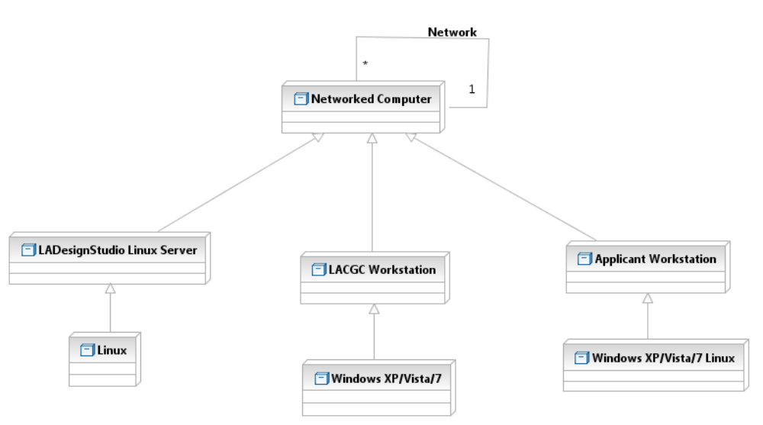

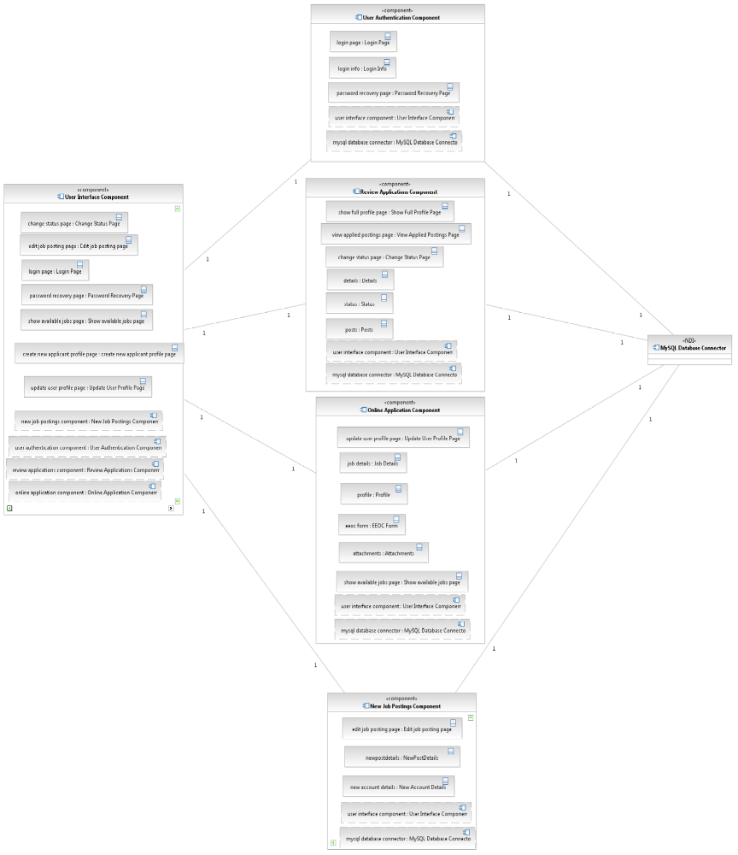 Figure 5: Software Component Class Diagram
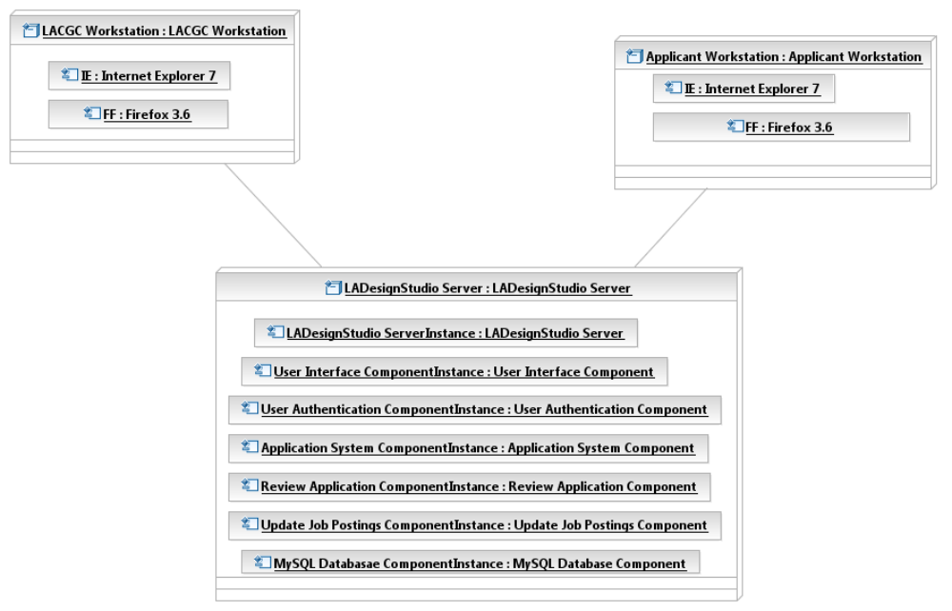

Figure 6: Deployment Diagram

Table 55: Hardware Component Description
Hardware Component | Description
LAGC Work Station | With the help of this workstation users sitting at LAGC workstation can access the system.
Applicant Workstation | With the help of this, users or applicants can access the website contents.
LA Design Studio Server | This is the server which is responsible for storing the data and website contents.

Table 56: Software Component Description
Software Component | Description
User Interface Component | The user interface component contains all the pages(classes) for the LACGC online application system.
User authentication Component | This component contains pages(classes) for the authenticating a user to access the system.
Review application component | This component contains all the pages(classes) required for reviewing application process.
Online Application Component | This component contains pages(classes) for online application process
New job posting Component | This component includes pages for adding/editing/deleting new job posts to the web site.
MySQL Database Component | MySQL database component contains all the applicant data and employee data.

Design Classes

Online Application System Classes
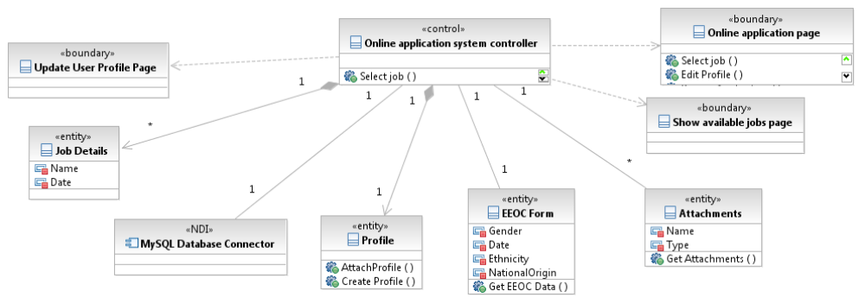Figure 7: Design Class Diagram
Table 57: Design Class Description
Class | Type | Description
Update User Profile Page | Boundary | A HTML page that provides user to update his profile.
Job Details | Entity | This contains the name and date of application for selected job/jobs.
Show Available Jobs Page | Boundary | A HTML page that will let the applicants view the job listings.
Online Application System Controller | Control | Responsible for managing the proper functionality of the Online system.
EEOC Form | Entity | This form contains the ethnicity information of the applicant
Profile | Entity | This will be the profile of the applicant
Attachments | Entity | These are the additional attachments required with the online application that user may want to attach.

Review Application Class Diagram

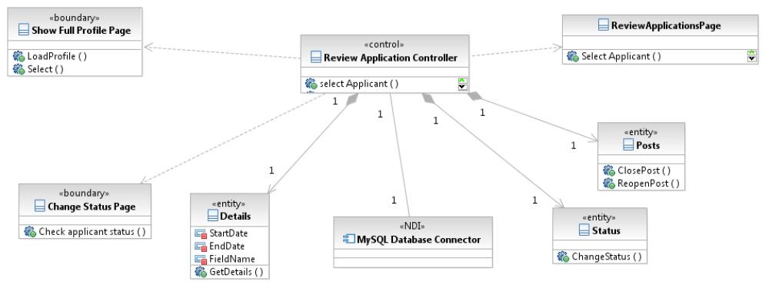 Figure 8: Design Class Diagram
Table 58: Design Class Description
Class | Type | Description
Show Full Profile Page | Boundary | A HTML page that will show the user his complete profile page
View Application Posting Page | Entity | This page will help user to view the postings to which user has already applied
Review Application Controller | Control | Responsible for managing the proper functionality of the Online system.
Details | Entity | This will contain the time duration.
Change Status Page | Boundary | HR can change the status of the job like interviewing, interviewed, waiting for interview etc
Posts | Entity | HR can either close the post or reopen based on the requirement.
Status | Entity | Status of the applicant can be seen using this page.

User Authentication Class Diagram

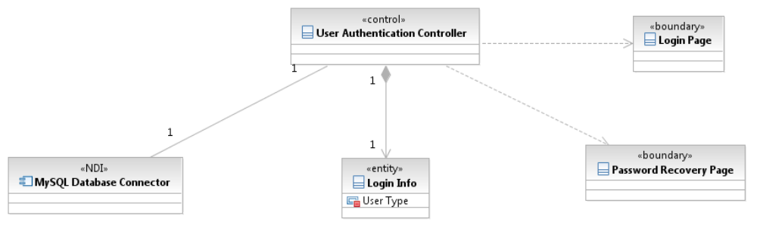 Figure 9: Design Class Diagram
Table 59: Design Class Description
Class | Type | Description
User Authentication Controller | Control | This is responsible for proper functioning of the system and keep an eye on whether there is proper connectivity etc.
MySQL Database Connector | Boundary | This is a database where the queried data is stored.
Login Page | Boundary | This page will let users login into the system
Password Recovery Page | Boundary | This page will help the users to retrieve their password if they have forgot.
Login Info | Entity | This will display the Login Information of the applicant.

New Job Posting Class Diagram

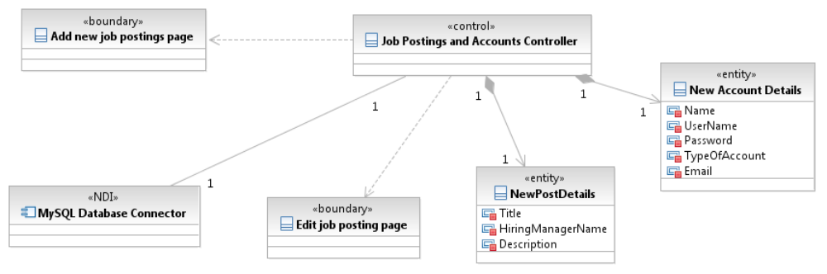Figure 10: Design Class Diagram

Table 60: Design Class Description
Class | Type | Description
Job Posting and Accounts Controller | Control | Responsible for checking and updating the Job Postings as the time goes by.
Edit Job Posting Page | Boundary | This will help the user to edit their job posting page
New Post Details | Entity | This will include the details of the new post which will be available to applicants to apply.
New Account Details | Entity | If new applicant applies then this page will help him to enter his details
Manage Accounts Page | Boundary | This page will help HR people to manage the accounts page.

Process Realization
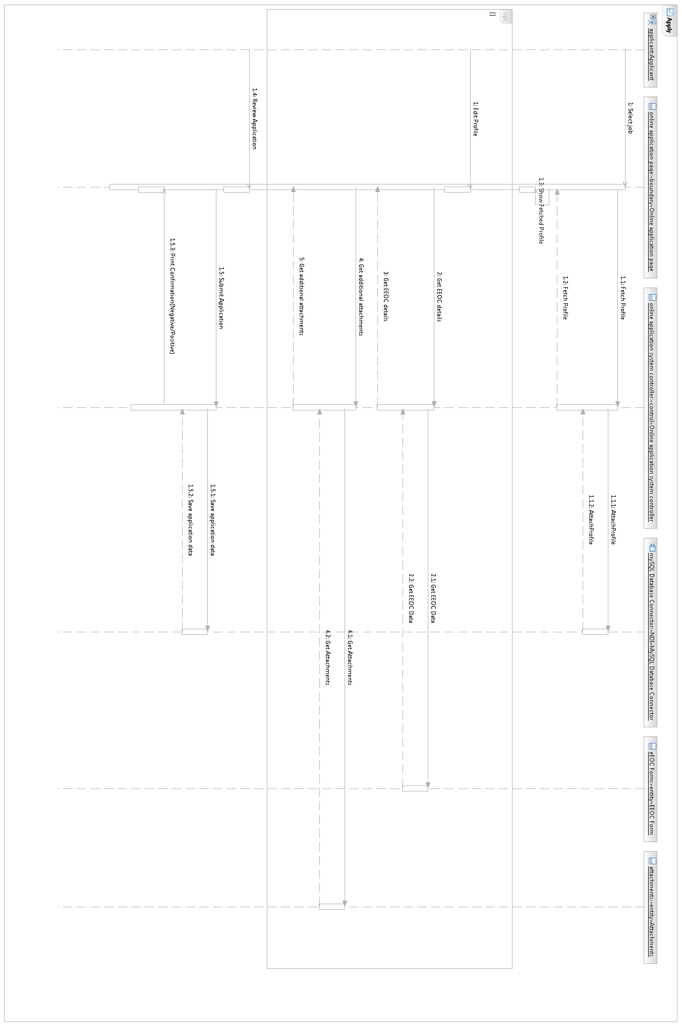
Figure 11 Online Application Sequence Diagram

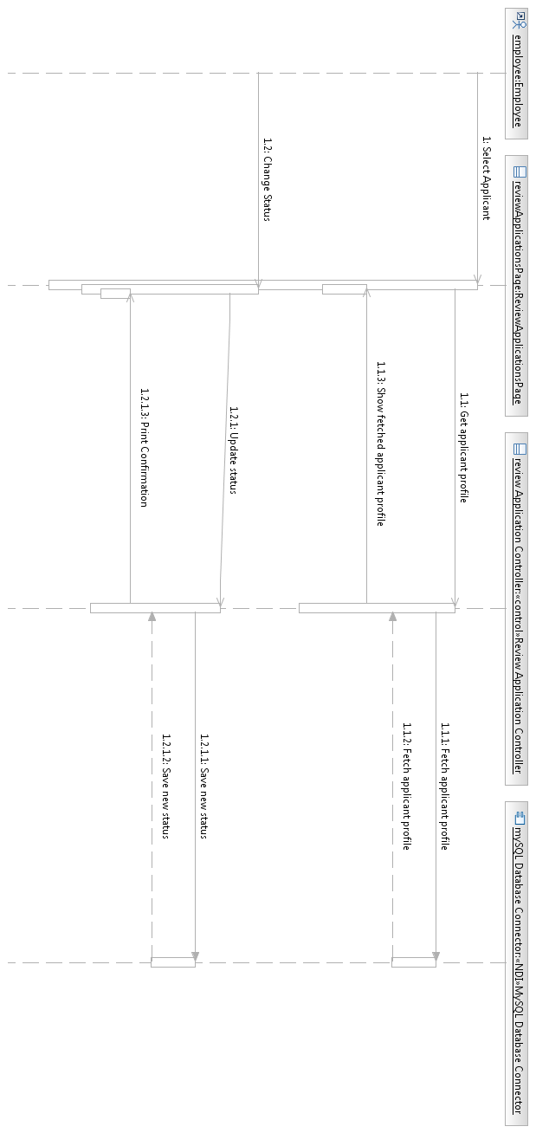
Figure 12 Review Application Online
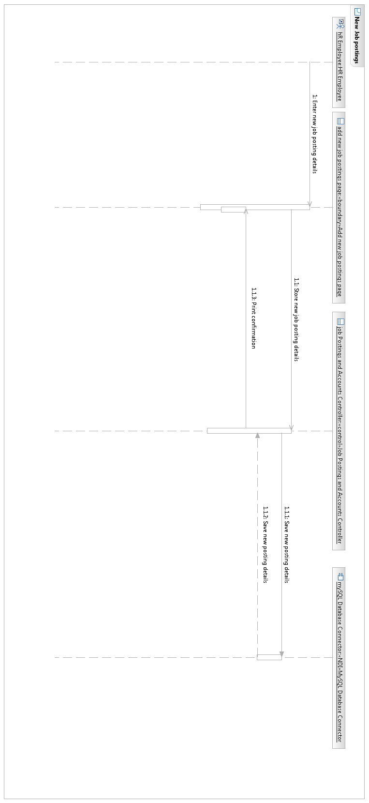
Figure 13 New Job Posting Sequence Diagram

Design Rationale

The client gave us a brief idea about what kind of system they want and have very less idea about the technicalities of the systems. The client already has a website which is just front end and does not contain any database. But for the new system they needed the database to store applicant data. We chose three tier architecture because it completely suited the client’s requirements as they wanted a system that is flexible with the current system they are using and 3 tier architecture provides that. The three tier architecture provides three layer design structure which helped design our system following way:

- Front end contains all the webpages that are visible to the users.
- Middle layer contains PHP platform which retrieves data from the database and connects it with the front end
- Back end consists of MySQL database which stores all the applicant data and employee details.

Architectural Styles, Patterns and Frameworks
Table 61: Architectural Styles, Patterns, and Frameworks
Name | Description | Benefits, Costs, and Limitations
Three tier architecture | The three tier architecture makes the logical separation between presentation layer, business logic layer and database layer. | The three tier architecture is basically used when effective design is needed. Some of the benefits of the three tier architecture are :  - Increased performance  - Flexibility  - Maintainability  - Reusability  - Scalability  Three tier architecture also has some disadvantages such as:  - There is more processing on the web server  - More complex structure  - More difficult to setup and maintain

